**9.ReactJs HOL Solutions**

**App.js**

import React from 'react';

import ListofPlayers from './components/ListofPlayers';

import ScoreBelow70 from './components/ScoreBelow70';

import OddPlayers from './components/OddPlayers';

import EvenPlayers from './components/EvenPlayers';

import ListofIndianPlayers from './components/ListofIndianPlayers';

const App = () => {

const flag = true;

const players = [

{ name: 'Jack', score: 50 },

{ name: 'Michael', score: 70 },

{ name: 'John', score: 40 },

{ name: 'Ann', score: 61 },

{ name: 'Elisabeth', score: 61 },

{ name: 'Sachin', score: 95 },

{ name: 'Dhoni', score: 100 },

{ name: 'Virat', score: 84 },

{ name: 'Jadeja', score: 64 },

{ name: 'Raina', score: 75 },

{ name: 'Rohit', score: 80 },

];

const IndianTeam = [

'Sachin1',

'Dhoni2',

'Virat3',

'Rohit4',

'Yuvraj5',

'Raina6',

];

const T20Players = ['First Player', 'Second Player', 'Third Player'];

const RanjiTrophyPlayers = ['Fourth Player', 'Fifth Player', 'Sixth Player'];

const IndianPlayers = [...T20Players, ...RanjiTrophyPlayers];

if (flag === true) {

return (

<div>

<h1>List of Players</h1>

<ListofPlayers players={players} />

<hr />

<h1>List of Players having Scores Less than 70</h1>

<ScoreBelow70 players={players} />

</div>

);

} else {

return (

<div>

<div>

<h1>Indian Team</h1>

<h1>Odd Players</h1>

{<OddPlayers players={IndianTeam} />}

<hr />

<h1>Even Players</h1>

{<EvenPlayers players={IndianTeam} />}

</div>

<hr />

<div>

<h1>List of Indian Players Merged:</h1>

<ListofIndianPlayers players={IndianPlayers} />

</div>

</div>

);

}

};

export default App;

**ListofPlayers.js**

import React from 'react';

const ListofPlayers = ({ players }) => {

return (

<ul>

{players.map((item, index) => (

<li key={index}>

Mr. {item.name} <span>{item.score}</span>

</li>

))}

</ul>

);

};

export default ListofPlayers;

**ListofIndianPlayers.js**

import React from 'react';

const ListofIndianPlayers = ({ players }) => {

return (

<ul>

{players.map((player, index) => (

<li key={index}>Mr. {player}</li>

))}

</ul>

);

};

export default ListofIndianPlayers;

EvenPlayers.js

import React from 'react';

export default function EvenPlayers([, second, , fourth, , sixth]) {

return (

<ul>

<li>Second : {second}</li>

<li>Fourth : {fourth}</li>

<li>Sixth : {sixth}</li>

</ul>

);

}

**OddPlayers.js**

import React from 'react';

export default function OddPlayers([first, , third, , , fifth]) {

return (

<ul>

<li>First : {first}</li>

<li>Third : {third}</li>

<li>Fifth : {fifth}</li>

</ul>

);

}

**ScoreBelow70.js**

import React from 'react';

const ScoreBelow70 = ({ players }) => {

const players70 = players.filter((item) => item.score < 70);

return (

<ul>

{players70.map((item, index) => (

<li key={index}>

Mr. {item.name} <span>{item.score}</span>

</li>

))}

</ul>

);

};

export default ScoreBelow70;

**App.js**

import React from 'react';

import ListofPlayers from './components/ListofPlayers';

import ScoreBelow70 from './components/ScoreBelow70';

import OddPlayers from './components/OddPlayers';

import EvenPlayers from './components/EvenPlayers';

import ListofIndianPlayers from './components/ListofIndianPlayers';

const App = () => {

const flag = true;

const players = [

{ name: 'Jack', score: 50 },

{ name: 'Michael', score: 70 },

{ name: 'John', score: 40 },

{ name: 'Ann', score: 61 },

{ name: 'Elisabeth', score: 61 },

{ name: 'Sachin', score: 95 },

{ name: 'Dhoni', score: 100 },

{ name: 'Virat', score: 84 },

{ name: 'Jadeja', score: 64 },

{ name: 'Raina', score: 75 },

{ name: 'Rohit', score: 80 },

];

const IndianTeam = [

'Sachin1',

'Dhoni2',

'Virat3',

'Rohit4',

'Yuvraj5',

'Raina6',

];

const T20Players = ['First Player', 'Second Player', 'Third Player'];

const RanjiTrophyPlayers = ['Fourth Player', 'Fifth Player', 'Sixth Player'];

const IndianPlayers = [...T20Players, ...RanjiTrophyPlayers];

if (flag === true) {

return (

<div>

<h1>List of Players</h1>

<ListofPlayers players={players} />

<hr />

<h1>List of Players having Scores Less than 70</h1>

<ScoreBelow70 players={players} />

</div>

);

} else {

return (

<div>

<div>

<h1>Indian Team</h1>

<h1>Odd Players</h1>

{<OddPlayers players={IndianTeam} />}

<hr />

<h1>Even Players</h1>

{<EvenPlayers players={IndianTeam} />}

</div>

<hr />

<div>

<h1>List of Indian Players Merged:</h1>

<ListofIndianPlayers players={IndianPlayers} />

</div>

</div>

);

}

};

export default App;

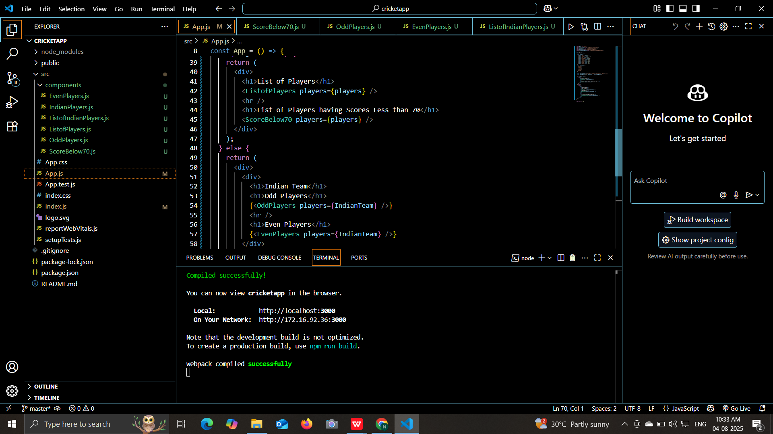

**OUTPUT:**

